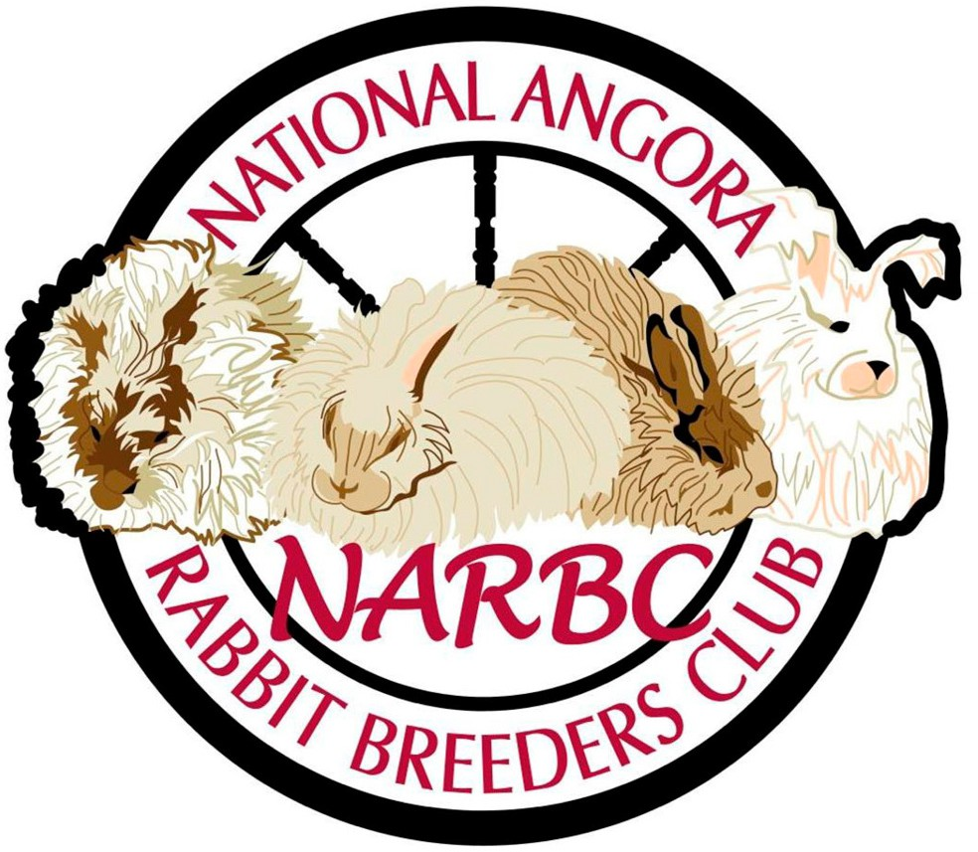
National Angora Rabbit Breeders Club, Inc.
Application for WSG Contest Sanction
Fiber Committee Chairperson
Angel Semerling
1706 Holiday Drive
PO Box 1897
Murray, KY 42071

Date of Show: Location: Name of Show/Event: Name of Host Angora Club: Name of Show Secretary: Name of WSG Chairperson (if different): Address:
Phone #:
Email:

Sanction fee is $5.00 payable to NARBC by check or PayPal narbc@yahoo.com . If paying by PayPal please include in the PayPal note section the payment is for a w/s/g sanction.
Total amount enclosed: $
General rules will be sent to you. Any additional information (entry fee, contact persons, deadlines) may be added for your event however the rules cannot be changed.
Entry forms, judging sheets, and placement reports will be emailed for your use or found on the website under the ‘WSG’ tab.
Placement reports must be returned to the Fiber Committee Chair (above) within 30 days of the show completion for sweepstakes points to count.

